FOR IMMEDIATE RELEASE

Lantor, Ltd., Launches Pill and Vitamin Organizer 3D Lenticular Case
Case features 56 compartments for organizing up to 8 weeks of pills or vitamins

Lomita, California, MARCH 27, 2017 - The team at Lantor, Ltd., is thrilled to announce the launch of their latest product, the Pill and Vitamin Organizer 3D Lenticular Case.
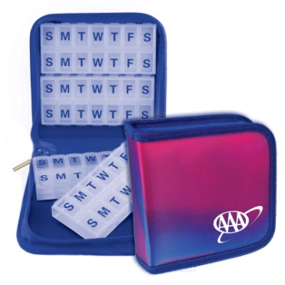
The all-new organizer features storage for up to 8 weeks of pills or vitamins in a compelling storage case that can be customized with logos for corporate clients.

Lantor, Ltd., has been a leading lenticular product printer for more than twenty years, and the company’s long list of all-star clients includes Lego, Home Depot, Porsche America, Microsoft, Sony, Toyota, and more. With products including retail store signs, table tents, postcards, business cards, posters, and more, Lantor, Ltd., is a one-stop shop for lenticular products for individual consumers and corporate clients alike.

With lenticular printing, a unique and color-changing surface is produced for an eye-catching look.

The Pill and Organizer 3D Lenticular Case can be used as an AM/PM organizer for pills or any other storage variation that clients find useful. Each premium organizer features a durable and high quality YKK zipper and a durable construction that have been designed for longevity.

Each organizer offers color coding labels, 5 medical information cards in a clear plastic card holder, and four 2-week pill boxes with magnets on the backside.

Lantor, Ltd., is offering customized options for corporate clients, as well.
More information is available at http://www.lenticularpromo.com/Medical-Pills-Vitamins-Travel-Case-Organizer-3D-Lenticular-s/725.htm and for corporate clients seeking promotional items can visit http://www.lenticularpromo.com

About Lantor, Ltd.
Lantor, Ltd., launched in 1994 and today serves as a leading full-service lenticular printer, offering specialty and consumer products to customers such as Home Depot, Sanrio, Inc., Lego, Roche, Porsche America, Toyota, Lexus, Microsoft, Sony, and more. Products include lenticular postcards, posters, retail case cards, retail store signs, table tents, business cards, and more.

Contact
Victor Jauch
Lantor, Ltd.
Phone: (800) 530 – 7544
Email: vj@lantorltd.com
Facebook: https://www.facebook.com/lantorltd
Instagram: https://www.instagram.com/lenticularpromo
Website: http://www.lenticularpromo.com
###

